

**MODULE 1**

**Reading and Writing Skills**

**Academic Texts and Texts and Text Structure**

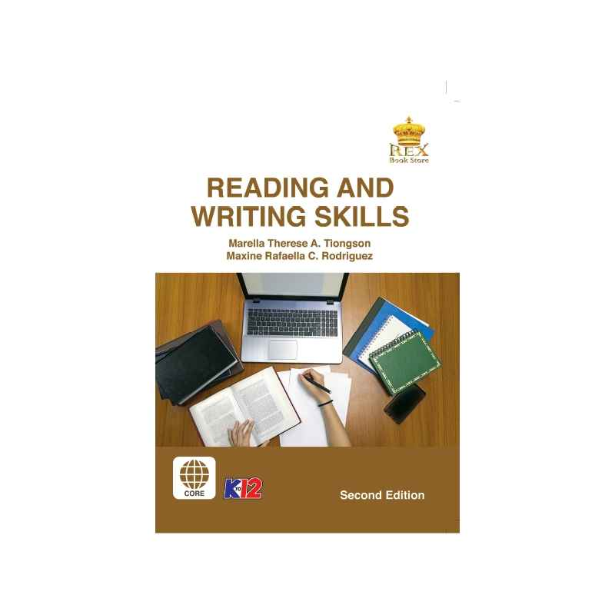

***Prepared by:***

**Mr. Reymart T. Metrillo**

Subject Teacher

**Name of Student**

**Grade,Section and Strand**

Date: ________________________

**MODULE 1: III:** **PATTERNS FOR DEVELOPING IDEAS IN WRITING and IV. PROPERTIES OF A WELL-WRITTEN TEXT**

OUTLINE-considered as a plan for writing; a summary that gives the essential feature of a text.

KINDS OF OUTLINE ACCORDING TO FORMAT

• Alphanumeric Outline- uses both letters and numbers as labels

• Decimal Outline- uses only numbers as labels

**Alphanumeric Outline**

1.

A.

1.

a.

b.

c.

B

C

**Decimal Outline**

1.

1.1

1.1.1

1.1.2

1.1.3

1.2

1.3

KINDS OF OUTLINE ACCORDING TO STRUCTURE

• Topic Outline-a systematic arrangement of ideas using broad topics in the form of words or simple phrases as headers



**Quiz 2   
Sentence Outline**- uses complete sentences as its entries; also known as expanded outline



**III. PATTERNS FOR DEVELOPING IDEAS IN WRITING**

* **Narration-** the most basic pattern of development; describes how, when, and where an event or occurrence actually happened
* **Process Analysis-**presents a series of steps in a procedure in chronological order and shows how this sequence of steps leads to particular results.
* **Cause and Effect-** discusses either the reasons for an occurrence or the observed or predicted consequences of an occurrence.
* **Comparison and Contrast-** organizes ideas based on how events, places, people, things, and concepts are similar to or different from one another
* Classification and Exemplification
* **Classification** - divides things into groups, classes, or categories
* **Exemplification-** provides examples and illustrations in order to further clarify or explain the concept or subject matter
* **Description-** the pattern of development which goes into details about a specific object, person, or location, in order to firmly set its appearance
* **Definition-** explains not just what something means or is, but also what something does, what something is used for, what something looks like, etc.
* **Problem-solution-** focuses on either a problem or solution in a particular area or situation
* **Persuasion-** convinces readers to agree to an argument or claim about a particular topic

**IV. PROPERTIES OF A WELL-WRITTEN TEXT**

**1. Organization**

• refers to the arrangement of ideas in a text

* Creating an outline of ideas before you start writing can help your work become organized.

**2. Coherence and Cohesion**

• refer to the connection of ideas and connection between sentences and between paragraphs

* In order for you to assure coherence and cohesion, you need to use transitional or cohesive devices.

**3.Appropriate Language Use**

• refers to the acceptable style of language for a particular form of text

**4. Proper Mechanics**

• refers to the conventions of writing which includes capitalization, punctuation, spelling, numerals,

**QUIZ 1**

**Direction:** Read definition and Identify what is being asked. Choose your answer inside the box below.

|  |  |  |
| --- | --- | --- |
| **Persuasion** | **Definition** | **Narration** |
| **Approproate Language use** | **Organization** | **Cause and Effect** |
| **Coherence and cohesion** | **Outline** | **Exemplication** |
| **Comparison and contrast** | **Process Analysis** | **Problem-solution** |
| **Description** | **Classification** | **Proper Mechanics** |

1. Refers to the arrangement of ideas in a text

2. The most basic pattern of development; describes how, when, and where an event or occurrence actually happened

3. Explains not just what something means or is, but also what something does, what something is used for, what something looks like, etc.

4. considered as a plan for writing; a summary that gives the essential feature of a text.

5. discusses either the reasons for an occurrence or the observed or predicted consequences of an occurrence.

6. provides examples and illustrations in order to further clarify or explain the concept or subject matter

7. refer to the connection of ideas and connection between sentences and between paragraphs

8. focuses on either a problem or solution in a particular area or situation

9. organizes ideas based on how events, places, people, things, and concepts are similar to or different from one another

10. divides things into groups, classes, or categories

11. refers to the conventions of writing which includes capitalization, punctuation, spelling, numerals, abbreviations, acronyms and contractions

12. the pattern of development which goes into details about a specific object, person, or location, in order to firmly set its appearance

13. presents a series of steps in a procedure in chronological order and shows how this sequence of steps leads to particular results.

14. convinces readers to agree to an argument or claim about a particular topic

15. refers to the acceptable style of language for a particular form of text

**ACTIVITY 2**

**Direction:** Read the following text below and make an outline of ideas based on what you have read. You can either choose between topic outline or/and sentence outline.

TEXT A

What makes an effective leader? To be sure, no one characteristic or trait defines an effective leader. It is true, however, that effective leaders get the most out of employees or group members by holding them to very high standards or expectations. Setting high standards increases productivity because people tend to live up to the expectations set for them by superiors. This is an example of the Pygmalion effect, which works in a subtle, often unconscious way.

When a managerial leader believes that a group member will succeed, the manager communicates this belief without realizing that he or she is doing so. Conversely, when a leader expects a group member to fail, that person will not usually disappoint the manager. The manager’s expectation of success or failure becomes a self-fulfilling prophecy. Thus it pays for a manager to expect the best from employees.

TEXT B

Despite its rapid spread, Islam is not a religion for those who are casual about regulations. On the contrary, adhering to the rules of Islam takes effort and discipline. One must rise before dawn to observe the first of five prayers required daily, none of which can take place without first cleansing oneself according to an established ritual or ceremony. Sleep, work, and recreational activities take second place to prayer. Fasting for the month of Ramadan, undertaking the pilgrimage to Mecca at least once in a lifetime, paying tax for relief of the Muslim poor, and accepting Islam’s creed require a serious and an energetic commitment. On the whole, the vast majority of Muslims worldwide do observe those tenets

**REFLECTION:**

The learners will write their personal insights about the lesson using the prompt below.

1. Will you able to write your own academic paper?

2. Let say that you have already made an academic paper. What techniques or knowledge about out topic for today did you use?